**Performance Assessment**

**Where Can We Find Opportunities For Better Performance?**

Edison Tian, Decire Santana, & Omar Martinez

City College of New York/CUNY, Colin Powell School for Civic and Global Leadership,

160 Convent Ave, New York, NY 10031

May 25th, 2024

# **I. Overview**

The economies of various regions are shaped by a complex interplay of causes and worldwide economic trends, which collectively determine the industries and sectors that flourish and contribute to the region's total economic development. It affects customer purchasing power, which has an impact on sales volumes and profits for companies. Of the regions investigated, Northern Europe has been shown to have the greatest order counts. This is explained by the comparatively higher minimum salaries, which increase the purchasing power of consumers. Furthermore, Northern Europe had two distinct, enormous increases in average revenue. These increases may have been caused by certain economic occurrences or seasonal sales that momentarily raised consumer expenditure. On the other hand, Central America also displayed high order counts, which might be connected to the consumer and economic policies of the region. Sales volume remained high in spite of what could be lower minimum salaries than in Northern Europe, perhaps because items were more reasonably priced and there were more people participating in trade. But Central America also saw high order counts, which could be related to the region's economic and consumer policies. Possibly since more individuals were engaging in trade and goods were more fairly priced, sales volume remained high despite what may be lower minimum salaries than in Northern Europe.

# **II. Results**

After creating, testing and modifying various sets of code we have found the following graphs to be most notable. We look to point out some key features amongst the following graphs that help visualize the data from the vast dataset. The trends shown in the data by indicators help us to interpret, analyze and come up with opportunities for the business to consider. Looking at Graph 1: Order Count Through Time we see that over the years across all regions the order count has declined year over year. Comparing that to Graph 2: Average Profit Ratio Per Order Region, we see that Southern Africa and East Africa are the two highest regions that can provide a higher than average profit ratio. Our first recommendation would be to mention that increasing sales and offering more of our resources to this part of the world can be seen as an opportunity to increase our sales. Additionally, we can see a clear outlier when it comes to Graph 3: Average Product Price Per Category where it reflects that the two distinct product categories are computers and strength training. We see this to be closely connected to Graph 4: Average Revenue By Months where certain product sales can be closely correlated to different seasons in the year. We would suggest that taking into account the high product price of these two items we can plan to capitalize on trends offering more technology in the holiday season and more fitness products in the warmer months to optimize our sales (Graph 5: Average Sales Per Year). Lastly, comparing shipping data collected from the dataset and graphed we can visualize an opportunity to save back on cost and simplify our delivery options. Examining Graph 6: Product Price Per Delivery result we see a clear loss of earnings with a major loss coming from canceled shipping orders, this can be as a result of double cost to send and retrieve packages, in comparison to on time shipping we save on cost and it shows on average. Moreover the mean shipping cost per delivery type from Graph 7: Shipping Per Delivery Type can help us understand that simplifying our options and offering our customers two shipping levels instead of four can potentially lead to more revenue from fees. The average cost between first and standard is approximately 25 dollars which could positively help us boost our sales.

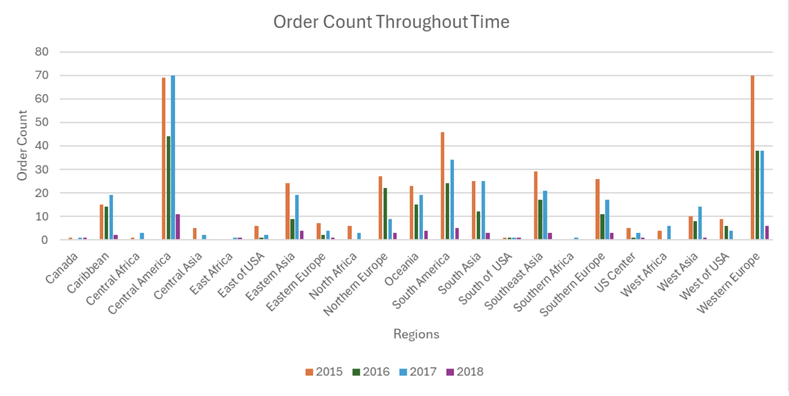

Graph 1: Region_Per_Year, Order_Count_Per_Region

*Average Profit Ratio Per Order Region*

# 

Graph 2: Order_Region, Order_Item_Profit_Ratio

*Average Product Price Per Category*

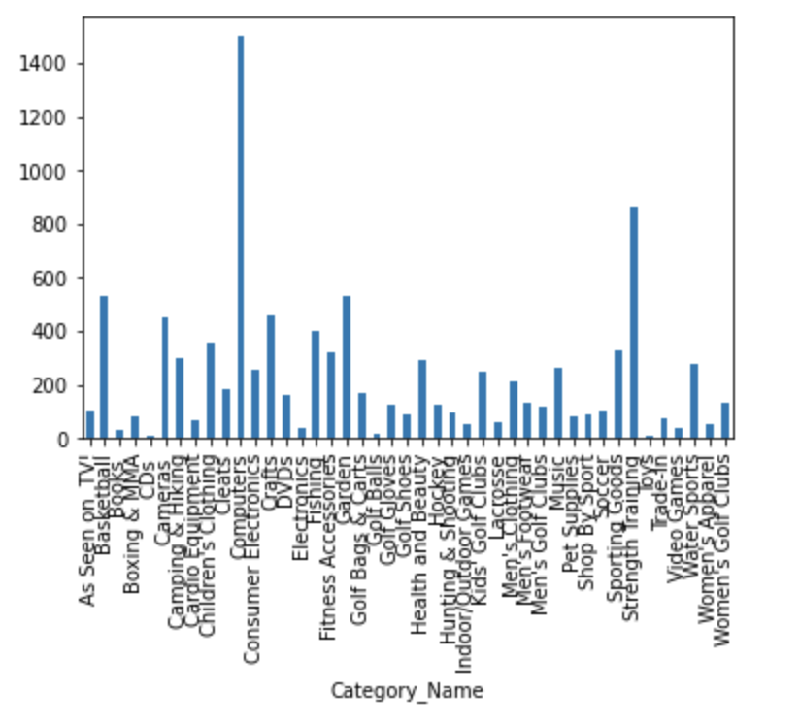

Graph 3: Category_Name, Product_Price

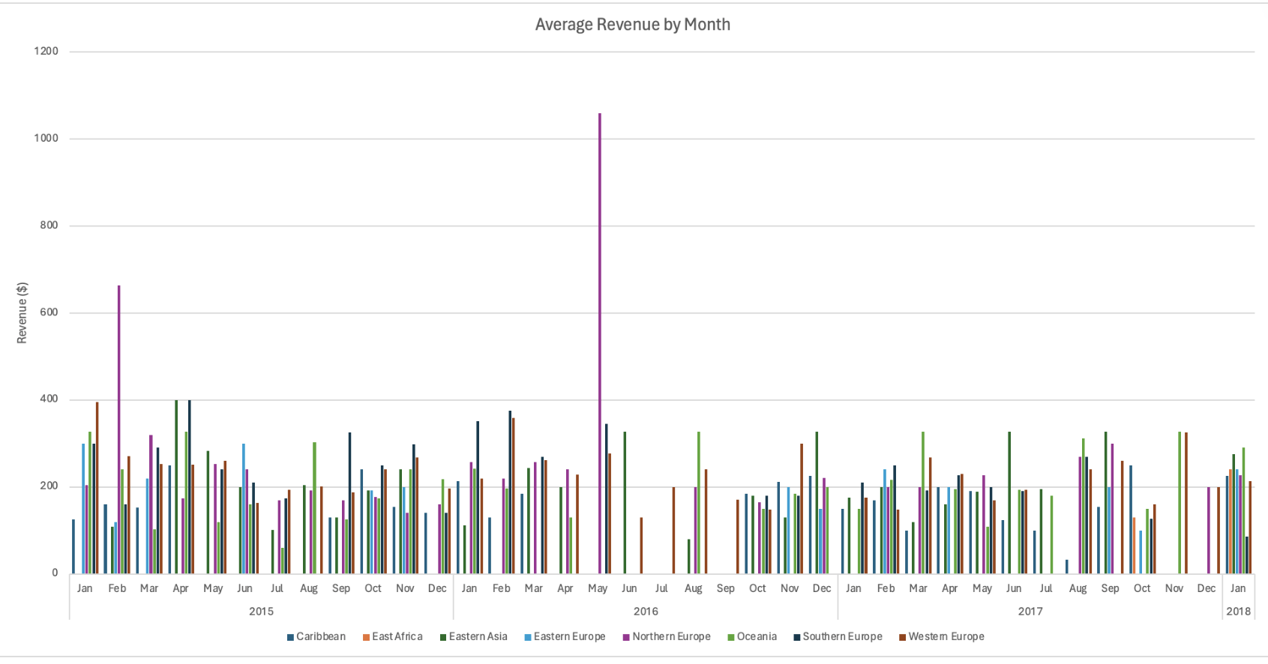

Graph 4:Revenue_By_Year, Revenue_Per Region,

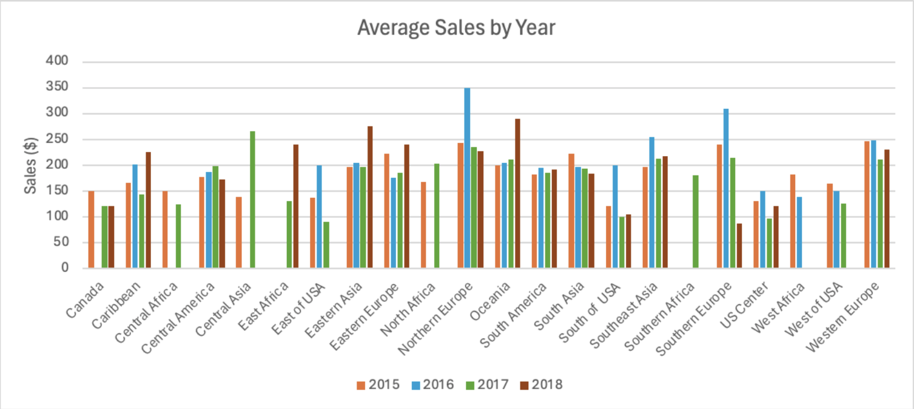

Graph 5: Region_Per_Year, Sales_Per_Region

*Product Price Per Delivery*

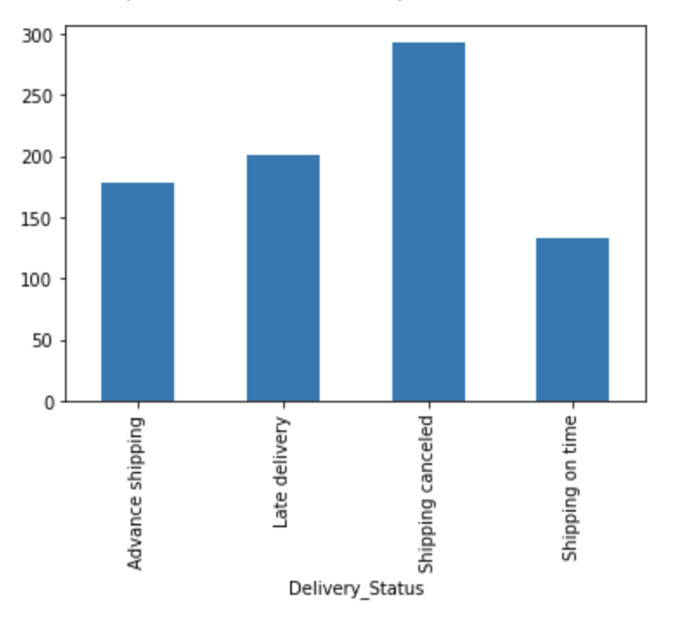

Graph 6: Product_Price, Delivery_Status

*Shipping Per Delivery Type*

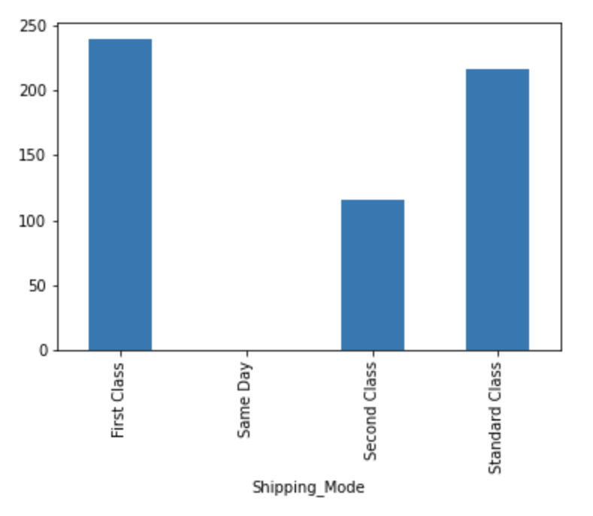

Graph 7: Shipping_Mode, Product_Price

**III. Methods**

Using a provided database we were able to extract reliable data to further analyze and help provide opportunities of success to determine areas in the business that can improve in sales performance. We first started by using Azure Data Studio to create a query where we used SQL to gather information. We gathered all our data from the Spr_2024 database on johndroescher.com, an online website that allowed us to view different sectors of the business such as Customer, Order, Store, Shipping and Product data. In our research we gathered raw data from the following categories: Order, Shipping and Product data. By using SQL code we were able to use select data to narrow down our spread, here we decided to make three separate distinctions comparing two areas of the business at a time. Implementing categories and using a Left Join to cross analyze the pair. Which we would then transfer to Jupyterlab where we would use python to graph our work. First creating code to make a connection from python to our database. Next, we transferred our SQL data into our python notebook, this allowed for our code to view the stored data. Then, we plotted several of our data using an independent and dependent variable to make numerous graphs. Lastly, creating the bar graphs now makes it easier to visualize, analyze and record potential trends and shifts that we could use to create our business recommendations on potential opportunities that could improve sales performance.

# **V. Summary**

# Overall, the economies of various regions are shaped by a complex interplay of causes and worldwide economic trends, which collectively determine the industries and sectors that flourish and contribute to the region's total economic development. Using a provided database, we were able to extract reliable data to further analyze and help provide opportunities of success to determine areas in the business that can improve in sales performance. In our research we gathered raw data from the following categories: Order, Shipping and Product data. By using SQL code we were able to use select data to narrow down our spread, here we decided to make three separate distinctions comparing two areas of the business at a time. After creating, testing and modifying various sets of code we have found the following graphs to be most notable. We look to point out some key features amongst the following graphs that help visualize the data from the vast dataset. The trends shown in the data by indicators help us to interpret, analyze and come up with opportunities for the business to consider.